**Data overview:**

<https://www.kaggle.com/datasets/dhanushnarayananr/credit-card-fraud>

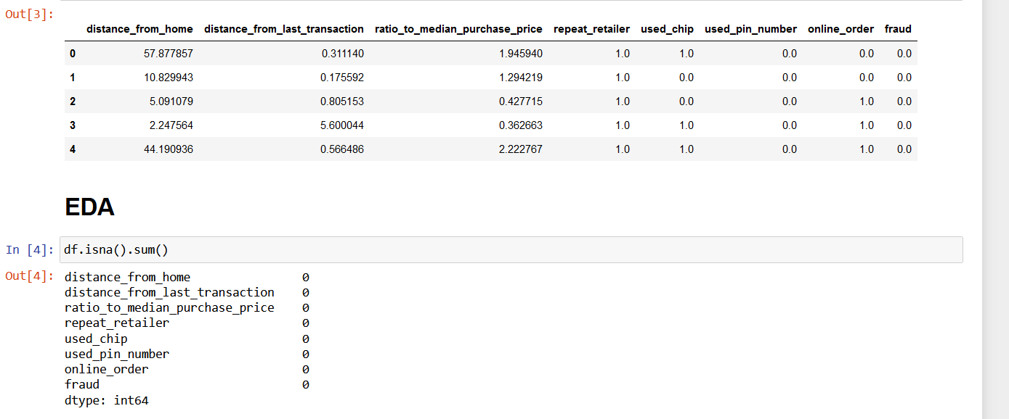

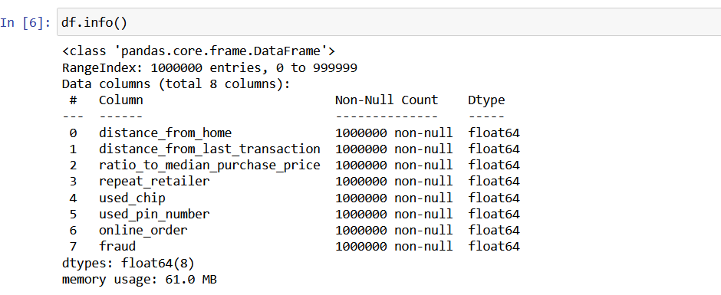

Dataset is well labelled and contains no missing values. Furthermore, it contains a large number of observations which will be great for training the model.

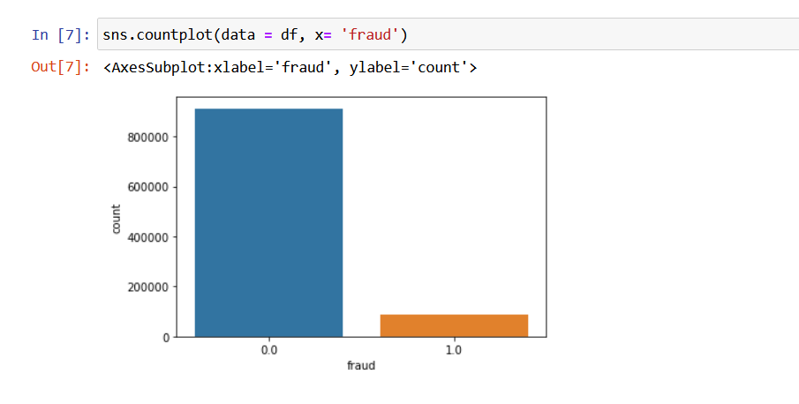

Data was unbalanced initially. SMOTE was used to create synthetic data to balance the minority class

**Modelling:**

Gradient boosting classifier was used to make predictions

**Performance:**

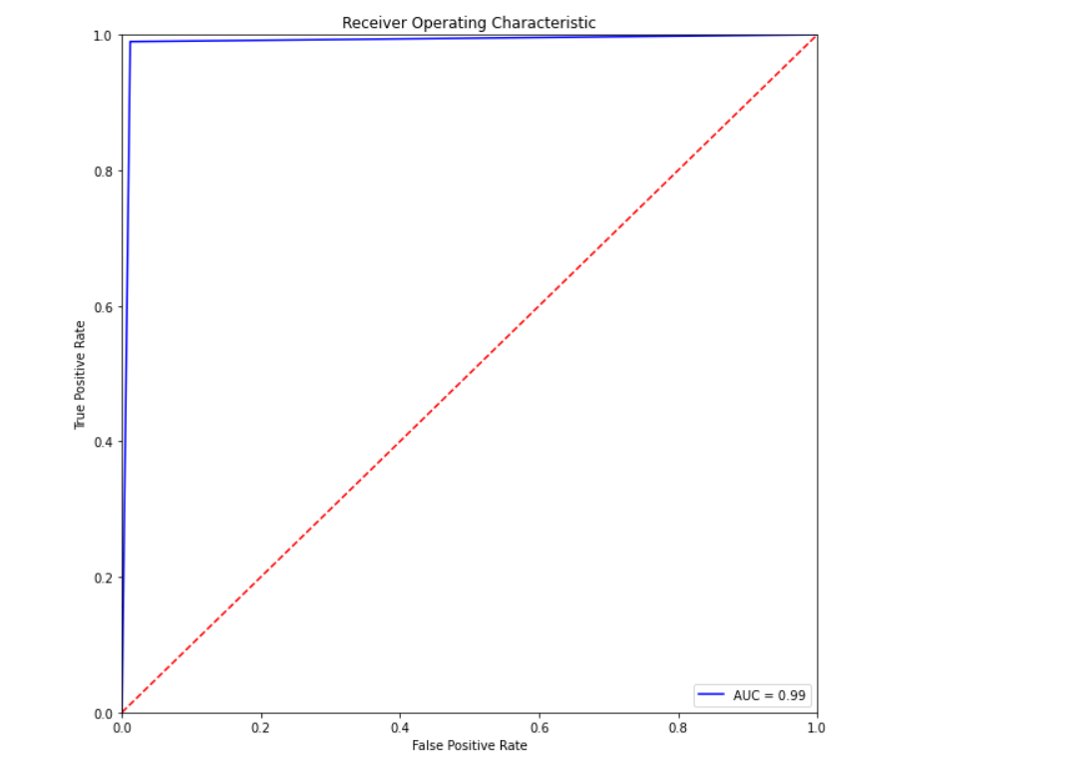

Model performed extremely well.

**Feature Importance:**

